**To Supply Leftover Food to Poor**

**COLLEGE NAME:** VET Institute Of Arts and Science (co-ed) College, Thindal, Erode.

**NM ID: 6F38079C0C12FF1981244C7427FF260F**

**COLLEGE CODE:** BRUBB

**TEAM ID:**

**TEAM MEMBERS:**

**Team Leader Name:** Manikandan. A

**Email:** manikandana23sit@vetias.ac.in

**Team Member1:** Kishore. D

**Email:** kishored23sit@vetias.ac.in

**Team Member2:** Varun.M

**Email:** varunm23sit@vetias.ac.in

**Team Member3:** Vishak. K

**Email:** vishakk23sit@vetias.ac.in

**Team Member4:** Madhankumar. G

**Email:** madhankumarg23sit@vetias.ac.in

1. **INTRODUCTION**
   1. **Project Overview**

* The Leftover Food Supply System is a Sales force-based application designed to efficiently manage the collection of surplus food and its distribution to the underprivileged, ensuring transparency, coordination, and minimal waste.
* Using Sales force, this solution simplifies the process of gathering excess food from donors and delivering it to those in need, promoting transparency and improving overall operational efficiency.

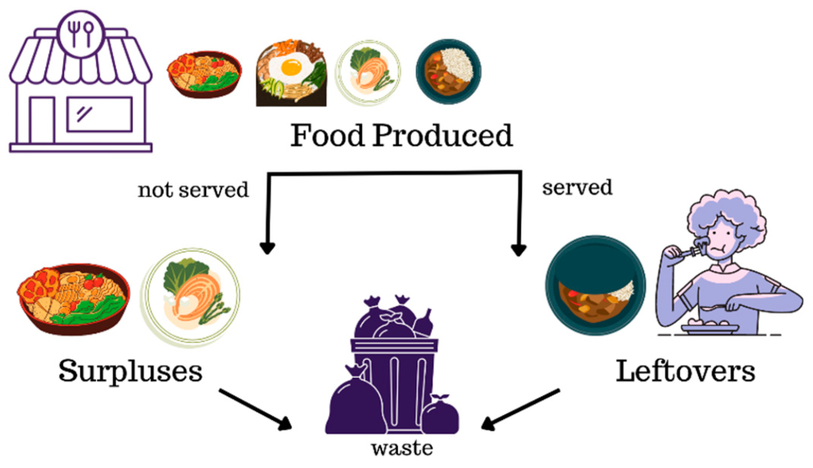

**1.2 Purpose:**

To reduce food wastage and alleviate hunger by creating an efficient, transparent platform using Sales force that connects food donors with organizations and volunteers for timely collection and distribution of surplus food to the poor.

**DEVELOPMENT PHASE**

**Creating Developer Account:**

**By using this URL -** [**https://www.salesforce.com/form/developer-signup/?d=pb**](https://www.salesforce.com/form/developer-signup/?d=pb)

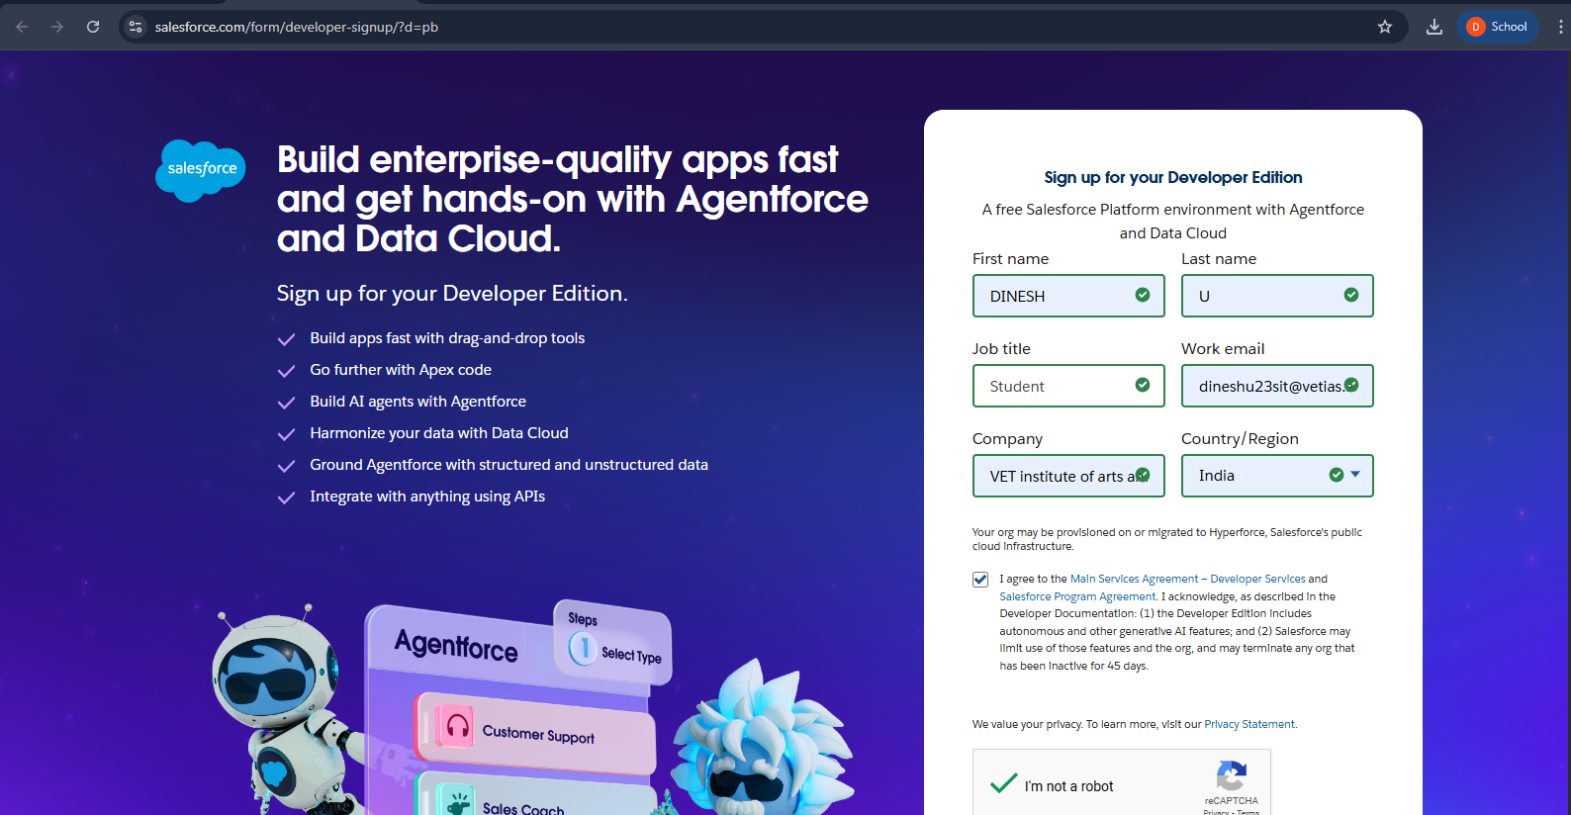

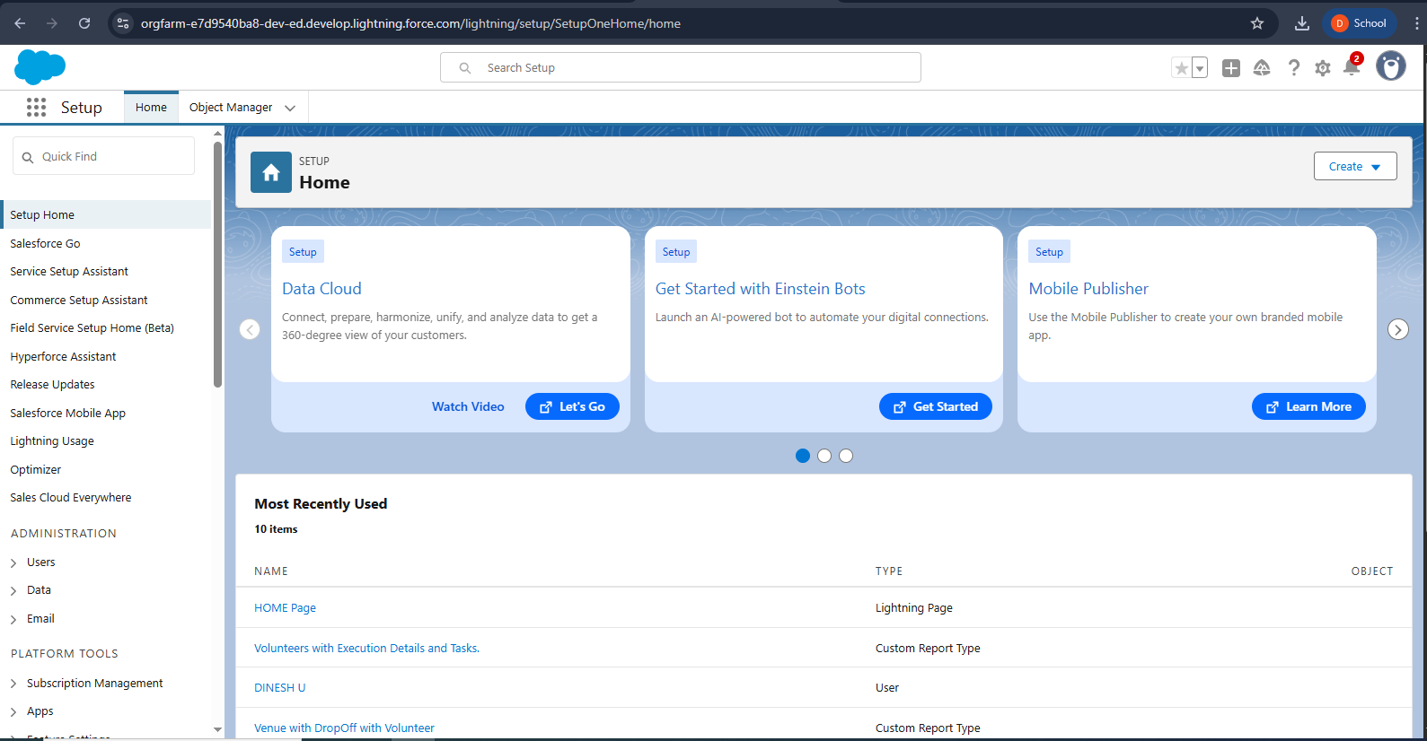

**Object:**

* To create an object:
* From the setup page > Click on Object Manager > Click on Create > Click on Custom Object.
* On Custom object defining page:
* Enter the label name, plural label name, click on Allow reports, Allow search.
* Click on Save.

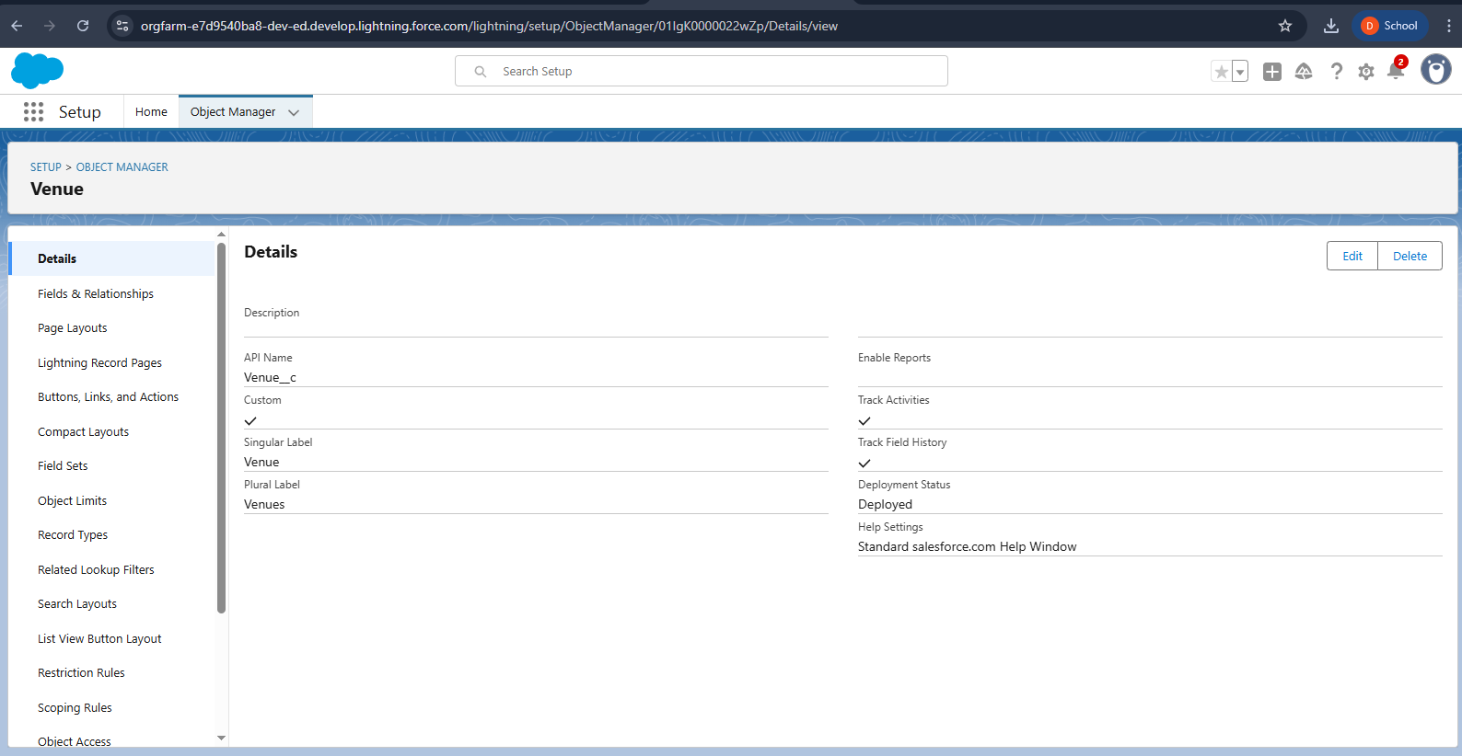

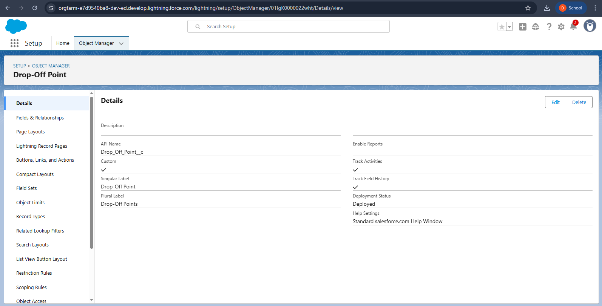

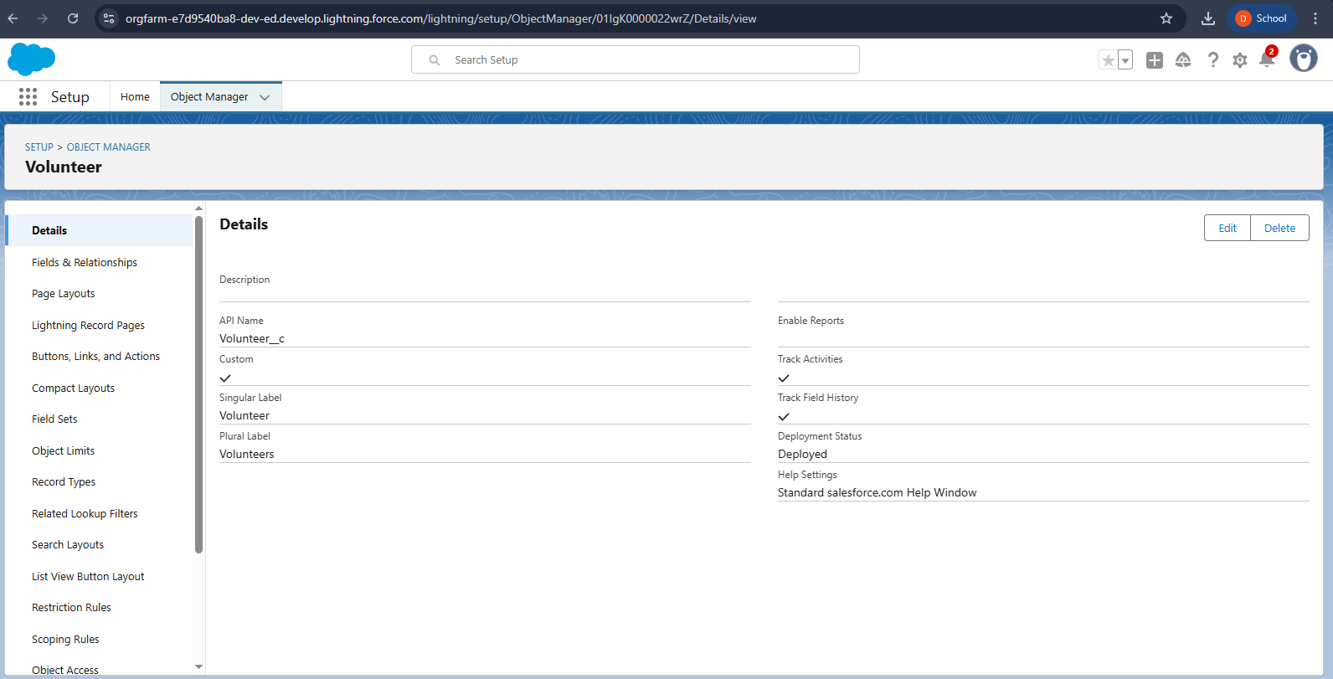

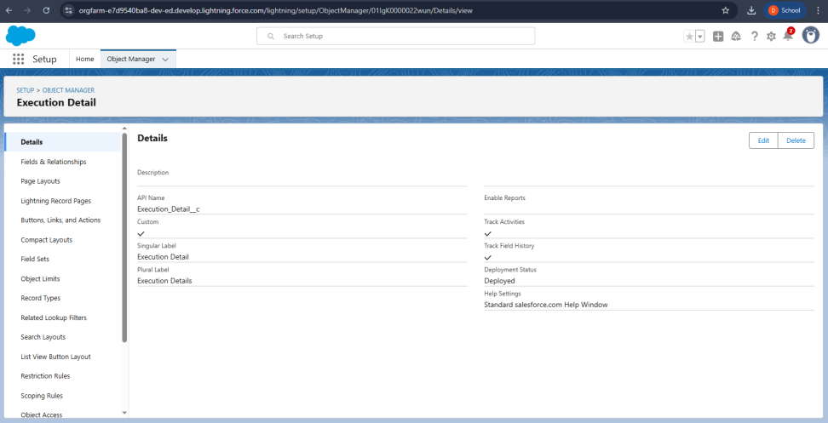

**Tabs:**

To create a Tab:(Venue)

* Go to setup page >> type Tabs in Quick Find bar >> click on tabs >> New (under custom object tab)
* Select Object(Venue) >> Select the tab style >> Next (Add to profiles page) keep it as default >> Next (Add to Custom App)  uncheck the include tab .
* Make sure that the Append tab to users' existing personal customizations is checked.
* Click save

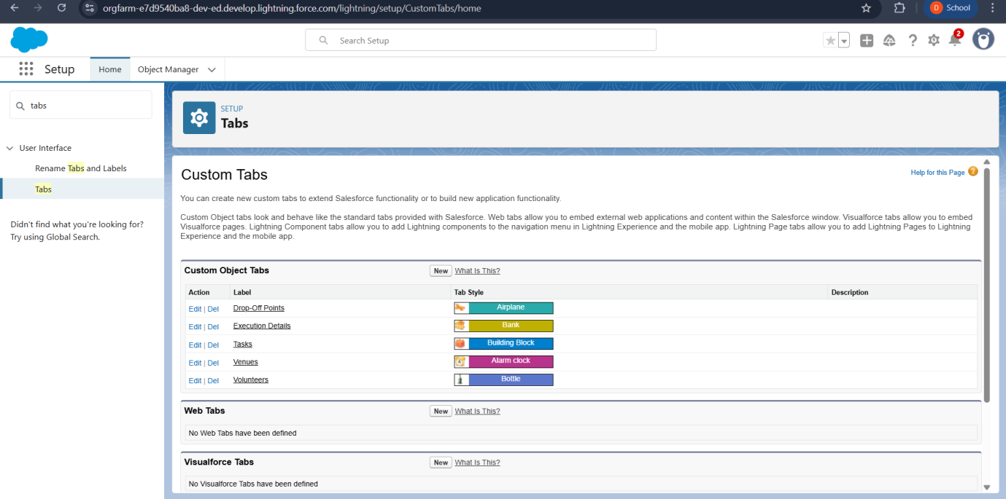

**The Lightning App:**

* Go to setup page >> search “app manager” in quick find >> select “app manager” >> click on New lightning App.
* Fill the app name in app details and branding as follow  
  App Name : FoodConnect  
  Developer Name : This will auto populated  
  Image : optional (if you want to give any image you can otherwise not mandatory) Primary color hex value : keep this default**.**
* .Then click Next  >> (App option page)Set Navigation Style as Standard Navigation >> Next.
* (Utility Items) keep it as default >> Next.
* To Add Navigation Items: Search for the item in the (Home, Venue, Drop-Off Point, Task, Volunteer, Execution Details, Reports) from the search bar and move it using the arrow button >> Next >> Next.
* To Add User Profiles: Search profiles (System administrator) in the search bar >> click on the arrow button >> save & finish.

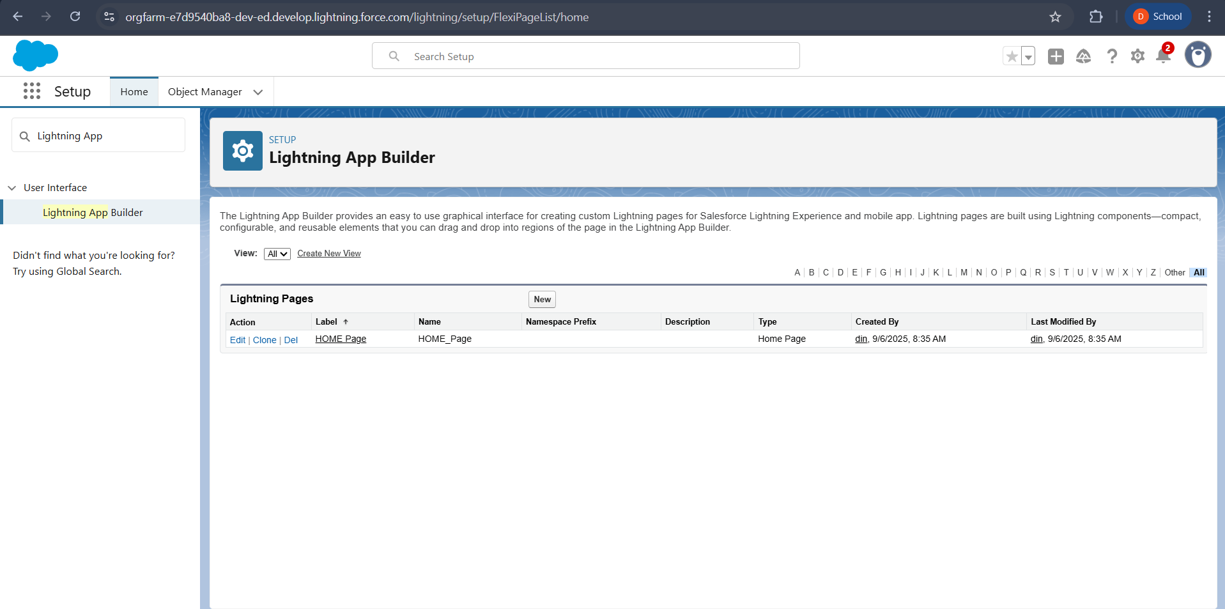

**Fields:**

**Creation of Relationship fields in objects :**

* **Creation of Lookup Relationship Field on Volunteer Object :**
* Go to setup >> click on Object Manager >> type object name(Volunteer) in the search  bar >> click on the object.
* Now click on “Fields & Relationships” >> New
* Select Master Detail relationship
* Select the related object “Drop-Off point” and click next.
* Field Name : Drop_Off_point
* Field label : Auto generated
* Next >> Next >> Save.

**Creation of Master Detail Relationship Field on Execution Details Object :**

* Go to setup >> click on Object Manager >> type object name(Execution Details) in the search  bar >> click on the object.
* Now click on “Fields & Relationships” >> New
* Select Master Detail relationship
* Select the related object “Volunteer” and click next.
* Field Name : Volunteer
* Field label : Auto generated
* Next >> Next >> Save.
* Creation of Master Detail Relationship Field on Execution Details Object :
* Go to setup >> click on Object Manager >> type object name(Execution Details) in the search  bar >> click on the object.
* Now click on “Fields & Relationships” >> New
* Select Master Detail relationship
* Select the related object “Task” and click next.
* Field Name : Task
* Field label : Auto generated
* Next >> Next >> Save.
* Creation of Lookup Relationship Field on Drop-Off Point Object :
* Go to setup >> click on Object Manager >> type object name(Drop-Off Point) in the search  bar >> click on the object.
* Now click on “Fields & Relationships” >> New
* Select Lookup relationship
* Select the related object “Venue” and click next.
* Field Name : Venue
* Field label : Venue__c
* Next >> Next >> Save.
* Creation of Lookup Relationship Field on Task Object :
* Go to setup>> click on Object Manager >> type object name(Task) in the search  bar >> click on the object.
* Now click on “Fields & Relationships” >> New
* Select Lookup relationship
* Select the related object “Venue” and click next.
* Field Name : Sponsored By
* Field label : Auto generated
* Next >> Next >> Save.
* Creation of Lookup Relationship Field on Task Object :
* Go to setup>> click on Object Manager >> type object name(Task) in the search  bar >> click on the object.
* Now click on “Fields & Relationships” >> New
* Select Lookup relationship
* Select the related object “Drop-Off point” and click next.
* Field Name : Drop-Off point
* Field label : Auto generated
* Next >> Next >> Save.

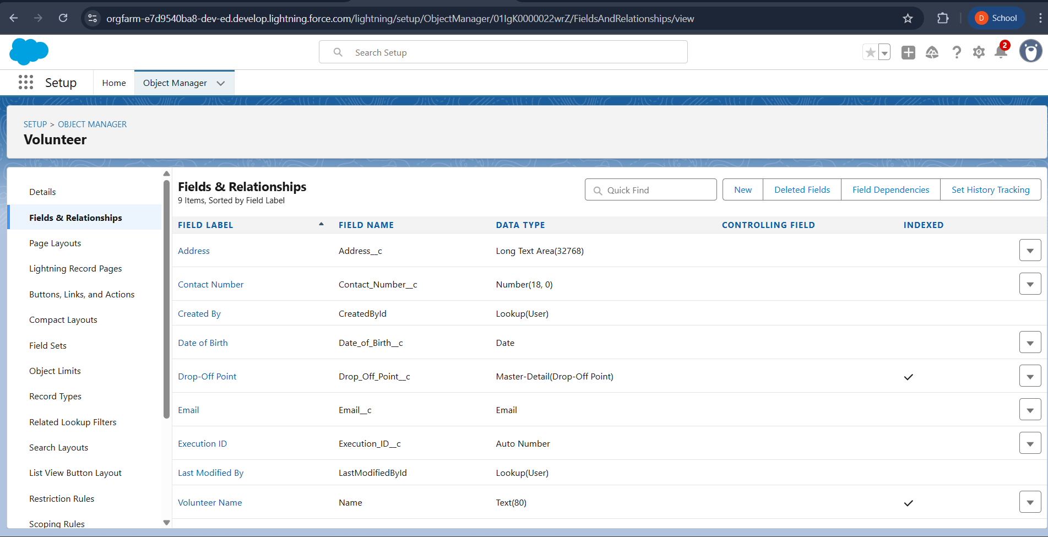

**Flows:**

**Create Flow to create a record in Venue object**

* Go to setup >> type Flow in quick find box >> Click on the Flow and Select the New Flow.
* Select the Screen flow. Click on create.
* Click on the ‘+’ icon in between start and end, and click on screen element.
* Under the Screen Properties:
* Label : Venue Details
* API Name : Venue_Details
* Now lets add components in this flow. Click on Text Component and name it as:
* Label : Venue Name
* API Name : Venue_Name
* Click on Email Component and name it as:
* Label : Email
* API Name : Contact_Email
* Click on Phone Component and name it as:
* Label : Phone
* API Name : Contact_Phone
* Click on Text Component and name it as:
* Label : Venue Location
* API Name : Venue_Location
* Click on Number Component and name it as:
* Label : Latitude
* API Name : Latitude
* Click on Number Component and name it as:
* Label : longitude
* API Name : longitude
* Next click on Done. This would like below
* 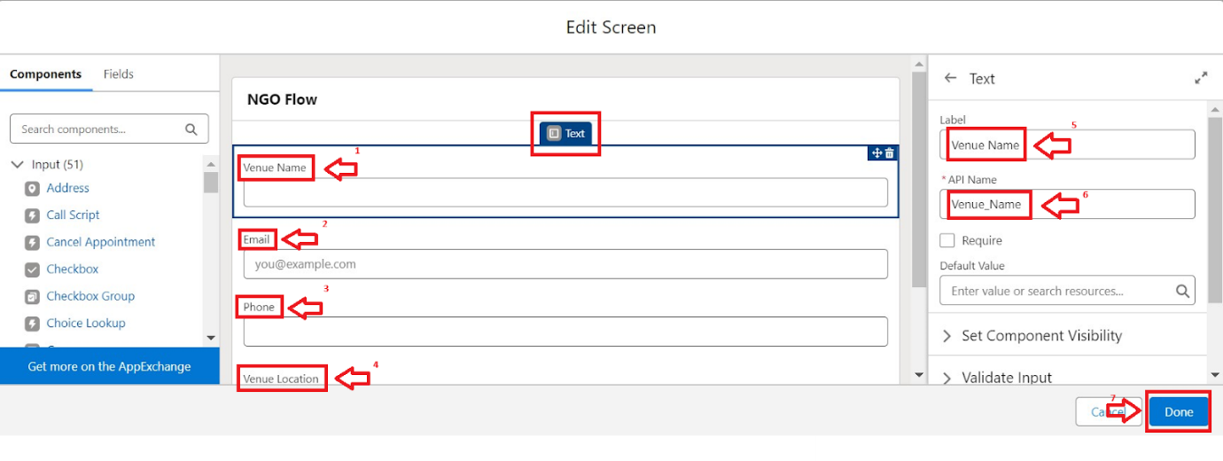
* Click on the ‘+’ icon in between Venue details and end, and click on create record element.
* Now label it as
* Label : Create Venue Record
* API Name : Create_Venue_Record
* How Many Records to Create : One
* How to Set the Record Fields : Use separate resources, and literal values
* Object : Venue
* Set Field Values for the Venue : Click on ‘Add Field’ 5 times
* Field : Value = Contact_Email__c : {!Contact_Email.value}
* Field : Value = Contact_Phone__c : {!Contact_Phone.value}
* Field : Value = Name : {!Venue_Name}
* Field : Value = Venue_Location__c : {!location}
* Field : Value = Location__Latitude__s : {!latitude}
* Field : Value = Location__Longitude__s : {!longitude}
* Click on Save as:

Flow Label : Venue Form

Flow API Name : Venue_Form

**Trigger:**

1. Log into the trailhead account, navigate to the gear icon in the top right corner.
2. Click on developer console and you will be navigated to a new console window.
3. Click on the File menu in the toolbar, and click on new >> Trigger.
4. Enter the trigger name and the object to be triggered**.**

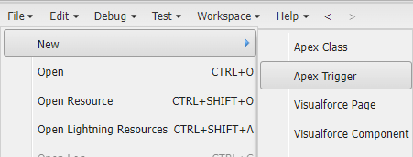

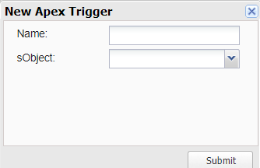

1. Enter Name : DropOffTrigger sObject: Drop-Off Point
2. Click on Submit.

**Trigger Code**

This Trigger is to assign Distance field to the Distance Calculation field. So that we can assign the distance in the sharing rules.)

**Code:**

trigger DropOffTrigger on Drop_Off_point__c (before insert) {

    for(Drop_Off_point__c Drop : Trigger.new){

        Drop.Distance__c = Drop.distance_calculation__c;

    }

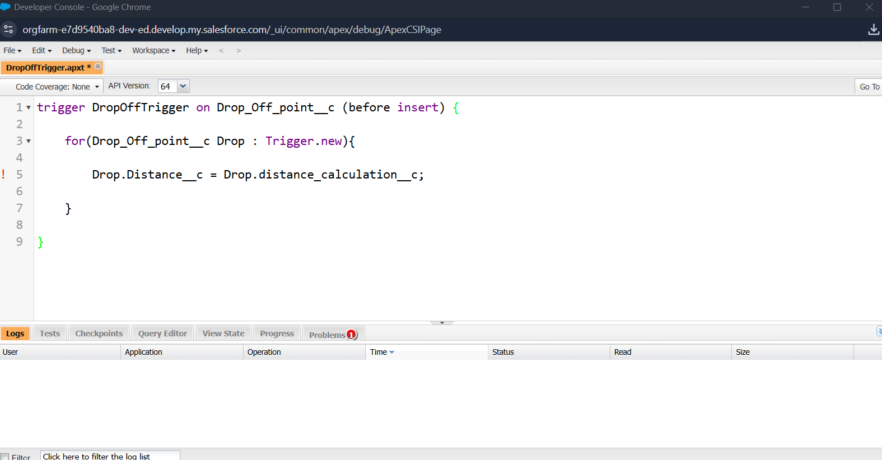

**Profiles :**

* Go to setup page >> type Profiles in Quick Find bar >> click on Profiles >> click on ‘S’
* Click on Clone beside Standard Platform User.
* Under Clone Profile:
* Profile Name : NGOs Profile
* Then click on Save

### Creation of Users:

* Go to setup page >> type users in Quick Find bar >> click on users>> New user.
* In General Information give details as: (Note : create users as per your wish NGO’s)

First Name : Iksha Foundation

Last Name : Iksha_Foundation

Alias : iiksh

Email : Give Your Email

Username : [ikshafoundation@sb.com](mailto:ikshafoundation@sb.com) (give the username different)

Nickname : Auto Populated

User License : Salesforce Platform

Profile : NGOs Profile

Active : Check

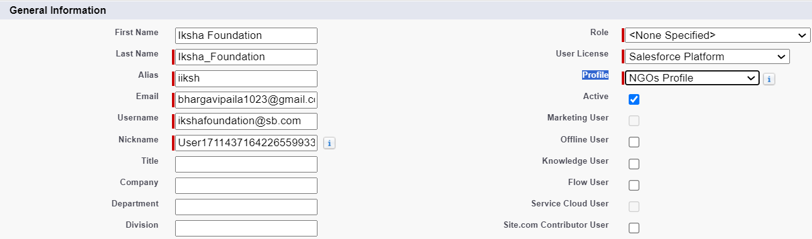

* Click on Save

### Public Groups:

* Go to setup page  >>  type Public Groups in Quick Find bar  >>  click on Public Groups >>  click on New.
* Under Group Information:
* Label : Iksha
* Group Name : Iksha
* Grant Access Using Hierarchies : Check
* In Search, Select Users.
* In Selected Members Add Iksha Foundation and System Administrator

### 

### Report Types:

### Creation of Report Types

* Go to setup page  >>  type Report Types in Quick Find bar  >> click on Report Types  >>  click on Continue   >>  Click on New Custom Report Type.
* In Define the Custom Report Type:
* Primary Object : Select Venues
* Report Type Label : Venue with DropOff with Volunteer
* Report Type Name : Venue_with_DropOff_with_Volunteer
* Description : Venue with DropOff with Volunteer
* Store in Category : Select Other Reports
* Deployment Status : Deployed
* Click on Next
* Near Click to relate another Object Select Drop-Off Points.
* And also select "A" records may or may not have related "B" records.
* Now again Near Click to relate another Object Select Volunteers.
* Now click on Save.

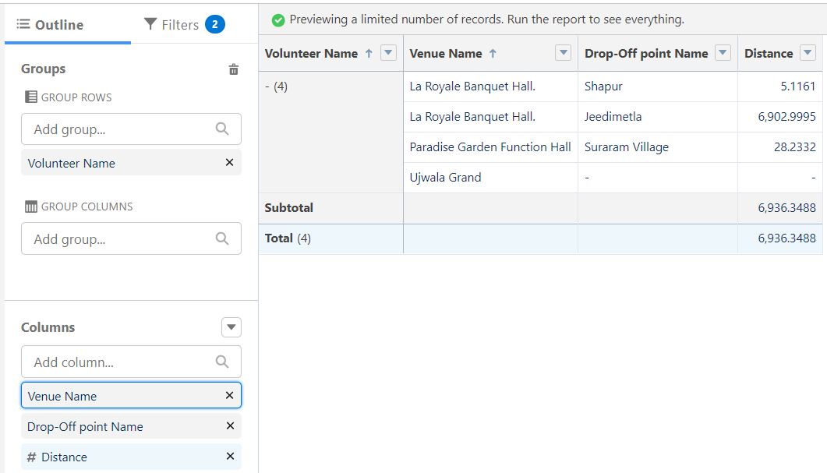 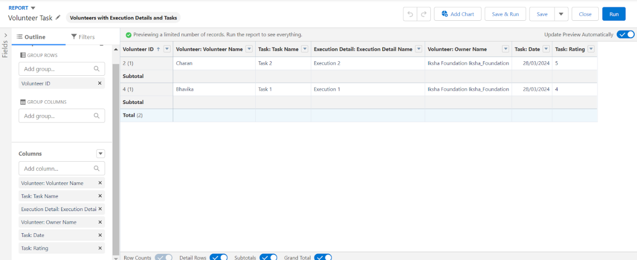

### Dashboards :

### Adding venue and Drop Off point Report to the Dashboard

### Adding venue and Drop Off point Report to the Dashboard

### Click on Widget and select Chart or Table

### In Select Report : Select Volunteer Task Report.

### Then click on select

### In Add Component:

### Display As : Select Line Chart

### Adding a Picture to the Dashboard (Optional)

### Click on Widget and select Image. Then click on Browse Files.

### Then Select the Picture you want to upload in this Dashboard.

### Then click on Save As :

### Name : Task Execution Details

### Click on Select Folder and select Custom Dashboards

### Click on Select Folder and then Save.

### 

### Sharing rules :

### Go to setup  >>  type Sharing Settings in quick find box  >>  Click on the Sharing Settings.

### Scroll down and find Drop-Off point Sharing Rules.

### Click on new near Drop-Off point Sharing Rules and Name it as:

### Label : Rule 1

### Rule Name : Rule_1

### Select your rule type : Select Based on criteria.

### Select which records to be shared:

### Field : Operator : Value = Distance : less than : 15

### Select the users to share with : Near Share With

### Public Groups : Iksha

### Click on Save.

### Click on new near Drop-Off point Sharing Rules and Name it as:

### Label : Rule 2

### Rule Name : Rule_2

### Select your rule type : Select Based on criteria.

### Select which records to be shared:

### Field : Operator : Value = Distance : greater than : 15

### Field : Operator : Value = Distance : less or equal : 30

### Select the users to share with : Near Share With

### Public Groups : NSS

### Click on Save.

### Click on new near Drop-Off point Sharing Rules and Name it as:

### Label : Rule 3

### Rule Name : Rule_3

### Select your rule type : Select Based on criteria.

### Select which records to be shared:

### Field : Operator : Value = Distance : greater than : 30

### Field : Operator : Value = Distance : less or equal : 50

### Select the users to share with : Near Share With

### Public Groups : Street Cause

### Click on Save.

### 

**Home Page:**

* Go to setup >> type Lightning App Builder in quick find box  >>  Click on the Lightning App Builder and Select the New.
* Select Home Page and give Label as HOME Page.
* Select Standard Home Page.
* Near Components search for Flow and Drag and Drop in Right Side Section..
* On the right hand side:

Flow : Venue Flow

* Near Components search for Dashboard, then Drag and Drop it in first Section.
* Click on Save and Activation, then click on App Default, then Add Assignments.
* Add FoodConnect App and then Save.
* FoodConnect Home Page would Look Like this

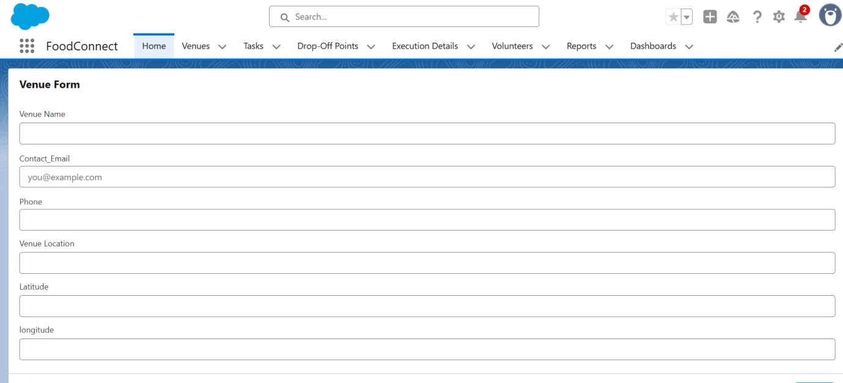

**Conclusion :**

**Summary of Achievements:**   The FoodConnect project successfully delivered a comprehensive solution to address food waste and hunger by leveraging the power of Salesforce technology. Key  accomplishments include:

* Streamlined Food Distribution: Developed a robust system to manage the  collection, allocation, and delivery of surplus food to underserved communities.
* Enhanced Volunteer Management: Implemented efficient task assignment and  tracking mechanisms to optimize volunteer engagement and contributions.
* DataDriven Insights: Created detailed reports and dashboards, providing  actionable insights into food redistribution metrics, volunteer participation, and  overall impact.
* Designed an intuitive Lightning App, ensuring a seamless  experience for all users, including donors, volunteers, and administrators.
* Operational Efficiency: Automated workflows and triggers to reduce manual effort,  improve accuracy, and ensure timely execution of tasks.

